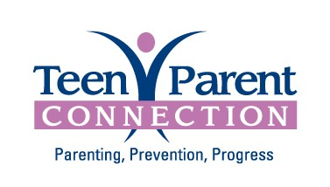
Referral Form
Teen Parent Connection offers doula services, childbirth education classes, group services and home visiting services for young parents 12-22 years old in and around DuPage County. Participation is voluntary and information is confidential.

Parent’s Name_________________________________
Date of Birth______________ Age: _______________

Baby’s Date of Birth/Due Date_______________________

Address________________________________________________

Town__________________________________________ Zip Code________________

Phone Number______________________________ Cell/Alternate Phone Number_______________________

Email: __________________________________________________________________________________

How did you hear about us? _____________________________________________________________________
Bilingual: Yes No
Language Preference: English Spanish Other: _______________
If you prefer Spanish speaking services your information may be shared with one of our community partners, including Dupage County Health Department and Family Focus.
Comments:

Name of Referring Agency & Contact Person: _________________________________
Please print
Phone Number___________________ ext.__________ Fax Number________________

I give ___________________ permission to release my information to Teen Parent Connection. I agree to have Teen Parent Connection contact me about their programs.
Verbal consent to contact given.
I give permission to Teen Parent Connection to share my information with a community partner in the case that I am ineligible for TPC programs.

Parent Signature__________________________________________________ Date____________
Witness Signature _________________________________________________ Date____________

