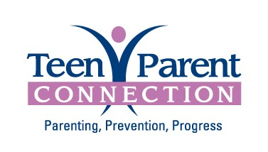
Referral Form
Teen Parent Connection offers doula services, childbirth education classes, group services and home visiting services for young parents in DuPage County. Participation is voluntary and information is confidential.

- Support Groups for parents ages 13 -22
- Childbirth Education Classes/Doula
for parents ages 13-22
- Healthy Families for parents ages 13-19
- Parent must be a DuPage County Resident

Parent’s Name_________________________________Date of Birth______________ Age: _______________

Baby’s Date of Birth/Due Date_______________________

Address________________________________________________

Town__________________________________________Zip Code________________

Phone Number______________________________ Cell/Alternate Phone Number_______________________

Email: __________________________________________________________________________________

How did you hear about us? _____________________________________________________________________
Bilingual: Yes No
Language Preference: English Spanish Other: _______________
If you prefer Spanish speaking services your information may be shared with one of our community partners including, Dupage County Health Department and Family Focus.
Comments:

Name of Referring Agency & Contact Person: _________________________________
Please print
Phone Number___________________ ext.__________ Fax Number________________

I give ___________________ permission to release my information to Teen Parent Connection. I agree to have Teen Parent Connection contact me about their programs.
Verbal consent to contact given.
Parent Signature__________________________________________________ Date____________
Witness Signature _________________________________________________ Date____________

